**Risk and Resiliency Batch Processor Flows Instructions**

The Risk and Resiliency batch processor tool requires a shapefile containing flow information from StreamStats. This process involves making a number of requests to the StreamStats batch processing service, and joining these flows to their respective culverts. The shapefile containing flows for the High Criticality Poor Condition culverts used for the pilot project are contained in a zip file called **Culverts_flows.zip**. This SOP outlines the process of creating a dataset of flow statistics for a new subset of culverts.

Instructions for creation of Batch Processor Flows input dataset:

* Navigate to the StreamStats Batch Processor tool: <https://streamstatsags.cr.usgs.gov/ss_bp/>
* You will need to submit your culverts in batches of fewer than 100 points. Larger jobs could lead to your job being cancelled or crashing the server entirely.

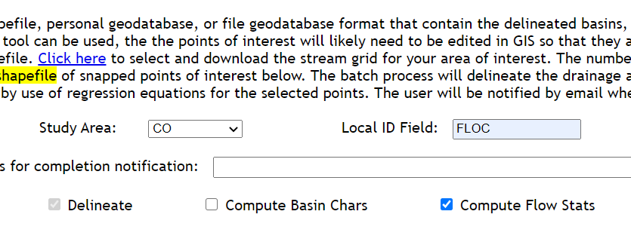

* Use FLOC as your Local ID field, as this will be the identifying field you will create your join on later

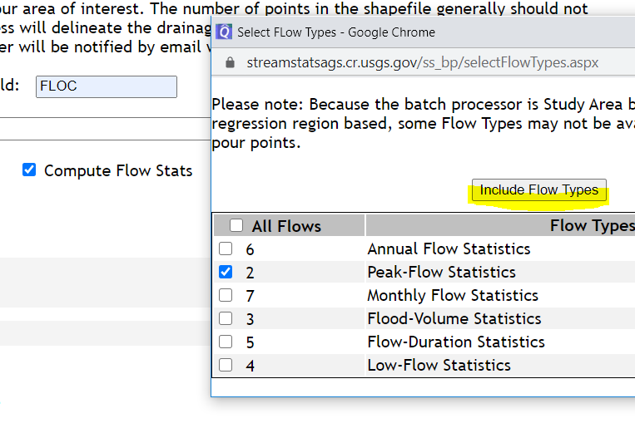

* Select Compute Flow types, then click option 2 Peak-Flow Statistics. **Make sure you click the Include Flow Types button when done**, or your request will run without flow types. Very frustrating to wait many hours just to end up with an output without flow stats.
* Select your individual shapefile files for your culverts sample and the options shown below, then submit to queue.

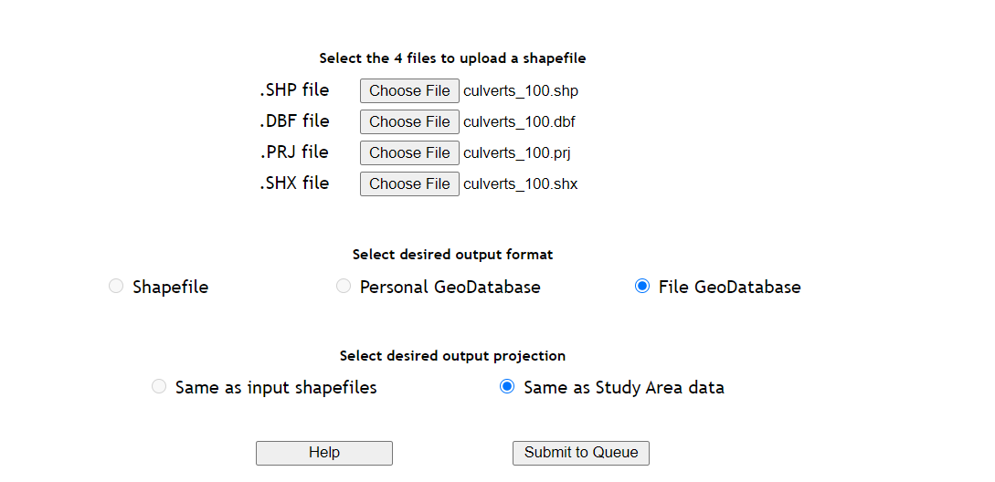

* You will receive your results from the batch processor as a .zip file. When you unzip the file you should have a geodatabase containing the highlighted files if it processed correctly.

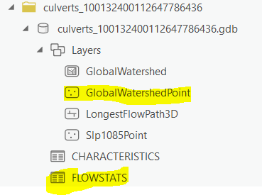

* Add the highlighted files to an ArcGIS Pro project

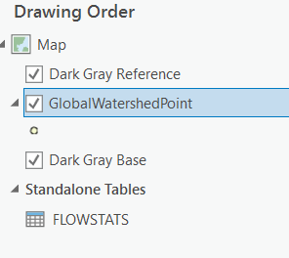

* Right-click on the FLOWSTATS table, select properties and then create the following definition query.

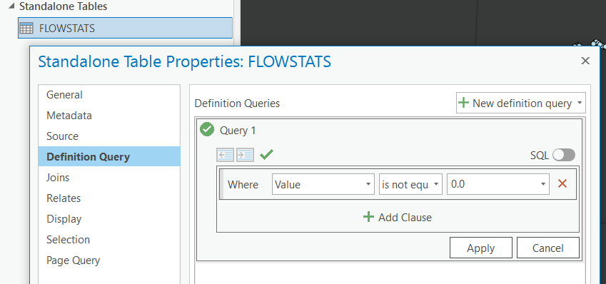

* We want our definition query to remove culverts which did not return flows from StreamStats by selecting only entries that do not equal a value of 0.0
* Next we want to join GlobalWaterShedPoint to the FLOWSTATS table by the Name field. This will create a point layer identified by the FLOC number of each culvert and the respective flow statistics for that culvert.

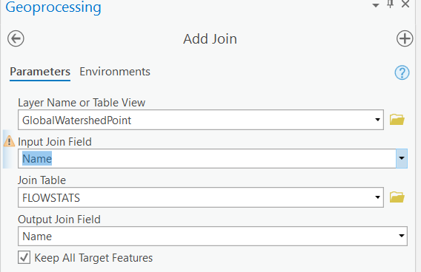

* Once you have joined these layers, right-click on GlobalWatershedPoint, select Data>Export Features and give your file a name identifying the subset of culverts this dataset will cover.
* If you have more than one subset of 100 culverts you would like to merge into a larger flow dataset, repeat the above steps for each set of 100 or fewer culvert requests.
* Once you have your output shapefiles, use the Merge geoprocessing tool to bring these all together into the final Batch Processor Flows Dataset input you will be using in the Risk and Resiliency model.